**MazharEAalaHazrat - Functional Specification and Design Documentation**

# Document Control

## Document Preparation

|  |  |  |  |
| --- | --- | --- | --- |
| **Version** | **Action** | **Name** | **Date** |
| 1.0 | Prepared by  Reviewed by  Owner Sign-Off | KHAN RAMZAN ALI  KHAN RAMZAN ALI | <<Date of Finalisation>> |

## Document Version History

|  |  |  |  |
| --- | --- | --- | --- |
| **Version** | **Date Released** | **Change Notice** | **Remarks** |
| 1.0 |  | Submitted |  |

## Confidential

This document has been prepared by **ABC** Technologies Pvt. Ltd. **ABC** hereby agrees to take utmost precautions while handling the data. This document contains sensitive data including, but not limited to, business strategies / logic, access rights / controls, confidential documents / formats and protected infrastructure details including web site locations, hardware and software details.

The aforesaid information, mentioned above, is confidential, privileged and only for the information of the intended recipient and may not be used, published or redistributed without the prior written consent of product owner. **ABC Technologies** will ensure that such information is not shared or disseminated to any third party.

*Table of Contents*

1 Document Control 1

1.1 Document Preparation 1

1.2 Document Version History 1

1.3 Confidential 1

2 Abbreviations 9

3 Project Introduction 10

3.1 Purpose of the requirement package 10

3.2 Business requirements overview 10

3.3 Stakeholders 12

4 Review & Approval 13

5 Requirements 14

5.1 Scope of Project 14

5.1.1 Hierarchy of Provident Fund Trust 14

5.1.2 Logical structure of Provident Fund Number 14

5.1.3 Uniqueness of employee records 15

5.1.4 Uniform set of identifiers and their extended attributes 15

# Abbreviations

| **Short Form Word** | **Full Form Words** |
| --- | --- |
|  |  |
|  |  |
|  |  |
|  |  |
|  |  |
|  |  |
|  |  |
|  |  |
|  |  |
|  |  |
|  |  |
|  |  |
|  |  |
|  |  |
|  |  |
|  |  |
|  |  |
|  |  |
|  |  |
|  |  |
|  |  |
|  |  |
|  |  |
|  |  |
|  |  |
|  |  |
|  |  |
|  |  |
|  |  |
|  |  |
|  |  |

# Project Introduction

## Purpose of the requirement package

The purpose of this document is to understand the challenges and pain areas of the existing MazharEAalaHazrat management applications and to capture any further requirements for new MazharEAalaHazrat management application. The requirements have been gathered from the relevant Business stakeholders and the IT Team of ABC.

## Business requirements overview

## Stakeholders

|  |  |  |
| --- | --- | --- |
| **Sr. No.** | **List of Stakeholders** | **Roles of Stakeholders** |
| **1** | Business Team | 1. To provide inputs and requirements for the development of the PF System, including transactional requirements such as process flows and accounting entries 2. To do UAT of the system at various stages of system development 3. To provide in-principal clearance before Go-Live of the system |
| **2** | IT Team | 1. To translate this document into a PF System, with the help of the Business team 2. To address any other relevant security requirement as per relevant Audit requirements 3. To provide in-principal clearance before Go-Live of the system |
| **3** | Business Head | 1. To ensure that all Business requirements are captured in this document, and provide inputs and guidance as necessary 2. To provide final clearance to Go-Live |
| **4** | IT Head | 1. To ensure that all Development and Security / Audit requirements are captured in this document, and provide inputs and guidance as necessary 2. To provide final clearance to Go-Live |
| **5** | OTPL Team | 1. To Document Requirements gathered during various review meetings and provide technical inputs with relevant stakeholders 2. Ascertaining feasibility of requirements along with the IT and Operations teams 3. To provide use cases / test cases which will be used during UAT of the system |

# Review & Approval

|  |  |  |  |
| --- | --- | --- | --- |
| **Review Version** | **Date Released** | **Change Notice** | **Remark** |
| 1.0 | <<Date of Finalisation>> | Submitted |  |
|  |  |  |  |

# Requirements

This project documentation links the requirement documentation to the project documentation, specifically the Scope Statement. This section is, therefore, a summary of the project Scope Statement.

## Scope of Project

During various meetings between **ABC** team members requirements mentioned hereinbelow were discussed. These requirements give a functional overview along with the accounting entries that get generated upon closure of the transactions. However the attributes mentioned here may change as part of the normalization process.

In the MazharEAalaHazrat Management System following points are to be implemented:

### H

Event 01 :

Urs-e-Razvi – 25th Safar al-Muzaffar 1447 Hijri

The sacred Urs of Imam-e-Ahl-e-Sunnat, Sayyedi AalaHazrat Imam Ahmed Raza Khan Fāzil-e-Barelvi radiAllahu Ta'ala anhu, is commemorated worldwide by the Ahl-e-Sunnat on the 25th of Safar al-Muzaffar.

At Khanqah-e-Hashmatiya, in Hashmat Nagar, Pilibhit Shareef, the Urs-e-Razvi and Urs-e-Hashmati are jointly celebrated with great spiritual fervour over three days — the 23rd, 24th, and 25th of Safar. Thousands of devoted followers gather during this blessed occasion.

The noble objective of this Urs is to spread the timeless teachings of Sayyidi AalaHazrat, deeply rooted in the Qur'an and Hadith, upholding the path of traditional Sunni Islam, and safeguarding the Ahl-e-Sunnat creed from deviant sects and misguided ideologies.



Event-2

Eid-e-Milad-un-Nabi ﷺ – 12th Rabi’ al-Awwal 1447 Hijri

The blessed occasion of Eid-e-Milad-un-Nabi ﷺ, marking the birth of the Mercy to the worlds, Sayyiduna Muhammad Mustafa ﷺ, is joyously and reverently celebrated by Ahl-e-Sunnat across the globe on the 12th of Rabi’ al-Awwal.

At Khanqah-e-Hashmatiya, in Hashmat Nagar, Pilibhit Shareef and Khanqah E Hashmatiya Dargah E Huzoor Masoom E Millat Pipra Mahim, this sacred day is observed with deep devotion and spiritual celebrations including Zikr, Maulood, Bayanaat and Juloos all done out of love and reverence for the Beloved Prophet ﷺ.

The true spirit of Eid-e-Milad lies in spreading awareness about genuine Ishq-e-Rasool ﷺ, reviving the love, mercy, and Sunnah of the Prophet ﷺ, and firmly refuting deviant ideologies that label Maulood as Bid’ah.

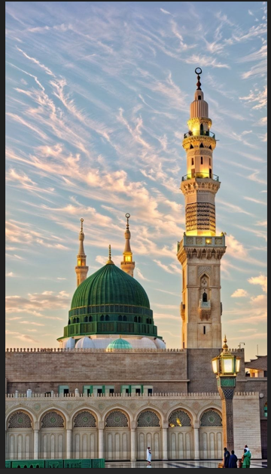

Event-3

Gyarhwin Shareef – 11th Rabi’ al-Thani 1447 Hijri

The sacred occasion of Gyarhwin Shareef, commemorating the noble Urs of Huzoor Ghaus-e-Azam, Sayyiduna Shaykh Abdul Qadir Jilani (radiAllahu anhu), is observed with immense devotion and reverence by Ahl-e-Sunnat worldwide on the 11th of Rabi’ al-Thani.

Just like Urs-e-Razvi Hashmati and Eid-e-Milad-un-Nabi ﷺ, thousands of devotees are served Langar Shareef on this auspicious day at Khanqah e Hashmatiyah, continuing the legacy of generosity and Barakah associated with Ghaus-ul-Azam.

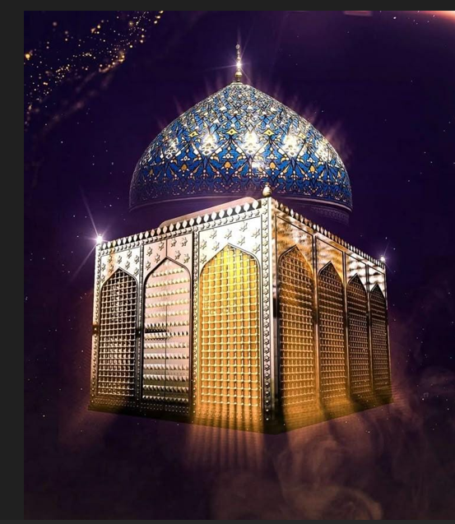

Home Page Box –description

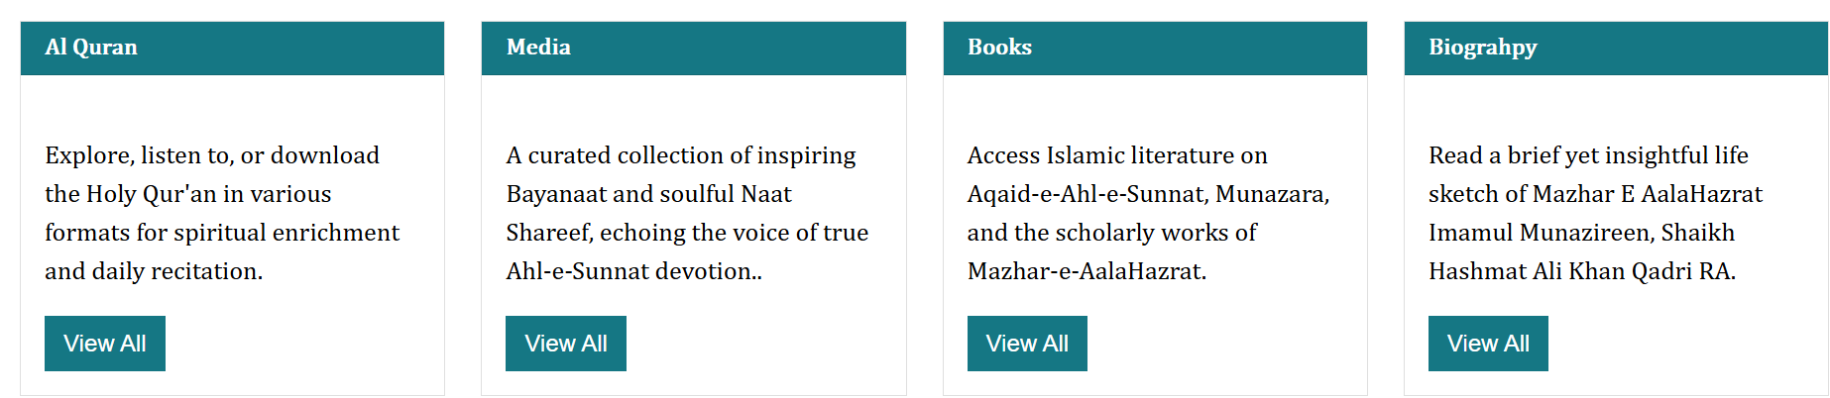

Al Quran

Explore, listen to, or download the Holy Qur'an in various formats for spiritual enrichment and daily recitation.

Media

A curated collection of inspiring Bayanaat and soulful Naat Shareef, echoing the voice of true Ahl-e-Sunnat devotion.

Books

Access Islamic literature on Aqaid-e-Ahl-e-Sunnat, Munazara, and the scholarly works of Mazhar-e-AalaHazrat, preserving Sunni legacy.

Biography

Read a brief yet insightful life sketch of Mazhar E AalaHazrat Imamul Munazireen, Shaikh Hashmat Ali Khan Qadri radiAllahu Ta'ala Anhu.

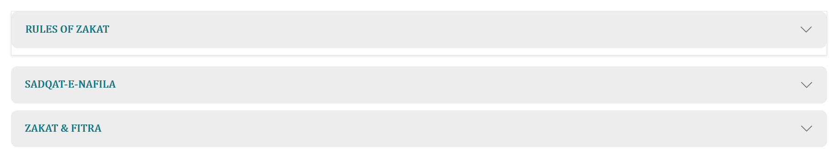

##### Quranic Verses

* وَمِمَّا رَزَقْنَاهُمْ يُنفِقُونَ

And the pious are those who spend in Our way from what We have given them.

* خُذْ مِنْ اَمْوَالِهِمْ صَدَقَةً تُطَهِّرُهُمْ وَ تُزَكِّیْهِمْ بِهَا

Take alms from their wealth; thereby you will cleanse them and purify them.

* وَ الَّذِیْنَ هُمْ لِلزَّكٰوةِ فٰعِلُوْنَ

And they who give Zakat are the ones who attain prosperity.

##### Hadith References

* Musnad Ahmad: Wealth without Zakat will become a bald snake on Judgment Day.
* Tabarani (Al-Awsat): Nations that withhold Zakat face famine.
* Hazrat Ali (RA): The poor suffer due to the negligence of the rich.

##### Legal Rulings (Masā’il)

1. Zakat cannot be given to disbelievers or certain sects. It will not be valid. (Fatāwā Razawiyyah Sharīf)
2. Conditions: Must be Muslim, sane, and adult. (Bahār-e-Sharī‘at)
3. Zakat must be given to a non-Hāshimi Muslim poor person. (Bahār-e-Sharī‘at)
4. Lunar year (Hijri) is used to calculate Zakat. Temporary dips in wealth don’t cancel obligation. (Bahār-e-Sharī‘at)
5. Zakat is Fardh. Denial is disbelief; neglect is sinful. (Bahār-e-Sharī‘at)

⚠️ **Important Note:** This platform is dedicated to Ahl al-Sunnah wa’l-Jamā‘ah. Zakat and donations are accepted only from Ahle-Sunnah. Individuals from other sects must refrain from

participating.

About Us

**MazharEAalaHazrat.com** is a sincere effort to share the true teachings of Islam under the blessed guidance of Shahzada-e-Huzur Mazhar-e-Aala Hazrat Junaid-e-Zamaán, Khaleefa-e-Hazrat Mufti-e-Aazam Hind, Hazrat Allama Mufti Shaikh Mohammad Nasir Raza Khan Sahab Hashmati, of Khanqahe Aaliya Hashmatiya, Pilibhit Sharif, and Founder and former Principal of Al-Jamiatul Hashmatiya, Pipra Mahim, U.P.

This platform is rooted in the spirit of **Maslak-e-Aala Hazrat**, the path of traditional Sunni Islam (Ahle Sunnat wal Jama'at), radiating love for Allah ﷻ and His Beloved Messenger ﷺ, reverence for the Sahaba and Ahle-Bayt, and a steadfast commitment to defending truth against misguidance.

### Our Inspiration

We take immense pride in being inspired by the spiritual Legacy of Mazhare Ala Hazrat shere be shahe ahle sunnat munazire azam alal itlaaq allama hashmat ali khan (رحمة الله عليه) — a towering figure known for his fearless clarity and unwavering dedication to **Maslak-e-Aala Hazrat**. Our mission includes spreading his message and safeguarding his original teachings.

### Our Mission

Our mission is to present Islam authentically and respectfully, using verified sources and highlighting the deep spiritual and intellectual traditions of Ahlus Sunnah wal Jama'ah.

* **Aqeedah** – Core Islamic beliefs based on the creed of Ahlus Sunnah wal Jama'ah
* **Radd-o-Munazara** – Scholarly rebuttals against deviant sects and ideologies
* **Defense of Islam** – Upholding truth and responding to misguidance
* **Teachings of Aala Hazrat** and **Mazhar-e-AalaHazrat**

**Disclaimer:** While this platform is spiritually guided by respected Shaikh Nasir Raza Khan, any mistakes, omissions, or misrepresentations are the fault of the website team and not the respected Shaikh. We remain learners, open to correction, and committed to continuous improvement.

### Join Us

We warmly welcome you to explore, learn, and grow with us on a journey fueled by sincerity, knowledge, and devotion — all for the pleasure of Allah ﷻ and His Beloved Messenger ﷺ.

Github Deployment :

<https://atdilakshan.medium.com/deploy-an-angular-app-to-github-pages-with-angular-cli-92a2d6fe6533>

# Angular

Angular is a popular **JavaScript framework** for building **single-page applications**.

# Deploy the angular app on GitHub

Deploying Angular applications to **GitHub pages** is a great way to host them for free.

First, you need the Angular Application.

Create the gh-pages git branch.

git branch gh-pages

Next, check out from the main branch to gh-pages to transfer all code.

git checkout gh-pages

Create the GitHub repository in your GitHub account.

Push the gh-pages to the remote repository.

git push -u origin gh-pages

Get the repo link.

Goto the settings for your repository.

In the pages tab, the Build and Deployment section sets the sources to Deploy from a branch.

Then change the branch to gh-pages and select the root folder.

# Install Angular-CLI-GHpages

After that, install the Angular-CLI-GHpages.

The angular-cli-ghpages package is a tool that the Angular CLI uses for deployment purposes.

Navigate back to your local project repository. Then install and run angular-cli-ghpages with this command:

ng add angular-cli-ghpages

# Deploy the App

Then deploy the app remotely.

To build the app in production, you must connect it to a remote server on GitHub.

Configure your app to a remote server by running the following command:

ng deploy --base-href=https://GithubUserName.github.io/GithubRepoName/

Now, you can find your Angular project on online. ([https://www.userName.github.io/repoName](https://githubusername.github.io/GithubRepoName/))

ng build --configuration production --base-href "https://mominali.github.io/MazharEAalaHazrat/

ng deploy --base-href=https://MominAli.github.io/MazharEAalaHazrat/

URL : https://MominAli.github.io/MazharEAalaHazrat/

https://github.com/MominAli/MazharEAalaHazrat.git

© Copyright 2025 by MazharEAalaHazrat.com